SMART RESTAURANT FOOD RECOMMENDATION SYSTEM

Project Report

1. Introduction

In today’s digital world, recommendation systems play an important role in enhancing user experience. Applications like food delivery platforms use intelligent systems to suggest items based on user preferences.

This project, *Smart Restaurant Food Recommendation System*, is a simple Python-based application that recommends food items based on user inputs such as food type, spice level, and cuisine. The system uses a basic scoring mechanism to provide relevant suggestions.

2. Objective

The main objectives of this project are:

To develop a simple recommendation system using Python
To understand how user preferences influence suggestions
To implement basic logic for filtering and ranking data
To provide meaningful suggestions even when no exact match is found

3. Scope of the Project

This project is designed for learning purposes and demonstrates the working of a basic recommendation system. It can be further extended into real-world applications like:

Food delivery apps
Restaurant management systems
Personalized user experience platforms

4. Methodology

The system follows a simple step-by-step process:

1. User Input Collection

Food type (Veg / Non-Veg)
Spice level (Low / Medium / High)
Cuisine preference

2. Data Processing

The system compares user input with available menu items

3. Scoring Mechanism

Each matching attribute increases the score
*Items with higher scores are selected

4. Recommendation Generation

If strong matches are found → display recommended dishes
If not → suggest alternative cuisines
Provide a random fallback suggestion

5. System Requirements

Hardware Requirements

Basic computer or laptop
Minimum 4GB RAM

Software Requirements

Python (version 3.x)
Any code editor (VS Code, PyCharm, or IDLE)

6. System Design
6.1 Data Structure
The menu is stored as a list of dictionaries:
Name of dish
Type (veg/non-veg)
Spice level
Cuisine

6.2 Modules Used

Input handling
Recommendation logic
Cuisine suggestion system
Error handling

7. Algorithm

Step 1: Start the program
Step 2: Take user input (type, spice, cuisine)
Step 3: Validate input
Step 4: Compare input with menu items
Step 5: Assign scores based on matches
Step 6: Sort and display recommended items
Step 7: If no match → suggest cuisines
Step 8: Display random suggestion
Step 9: End program

8. Implementation

The project is implemented using Python with:

* Lists and dictionaries for data storage
* Functions for modular design
* Loops and conditions for logic building
* Exception handling for error-free execution

9. Features

* User-friendly input system
* Intelligent recommendation logic
* Alternative cuisine suggestions
* Random fallback recommendation
* Input validation and error handling

10. Advantages

* Simple and easy to understand
* Lightweight and fast
* Beginner-friendly project
* Can be extended easily

11. Limitations

* Uses static dataset (no real-time data)
* No machine learning integration
* Limited personalization
* No graphical interface

12. Future Enhancements

* Add machine learning algorithms
* Integrate database (MySQL/SQLite)
* Develop GUI using Tkinter
* Build web application using Flask/Django
* Add user login and history tracking
13. Conclusion: The Smart Restaurant Food Recommendation System demonstrates how basic programming concepts can be used to build a simple yet effective recommendation system. It provides a foundation for developing more advanced and intelligent systems in the future.

14. References
* Python Documentation (https://docs.python.org)
* Basic tutorials on recommendation systems
* Online learning resources and notes

15. Screenshots

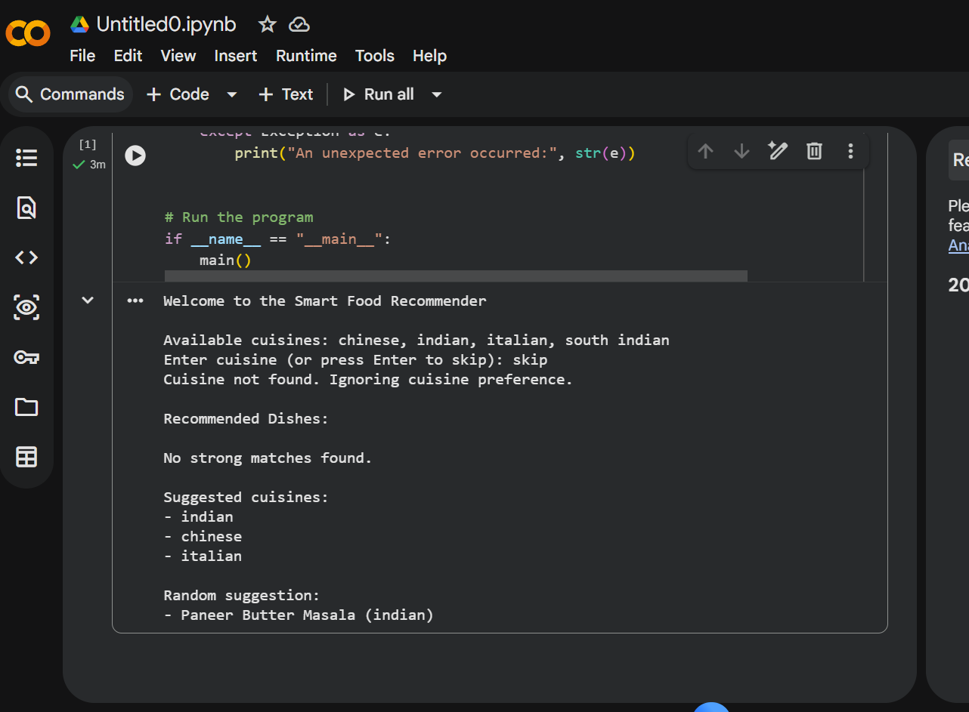

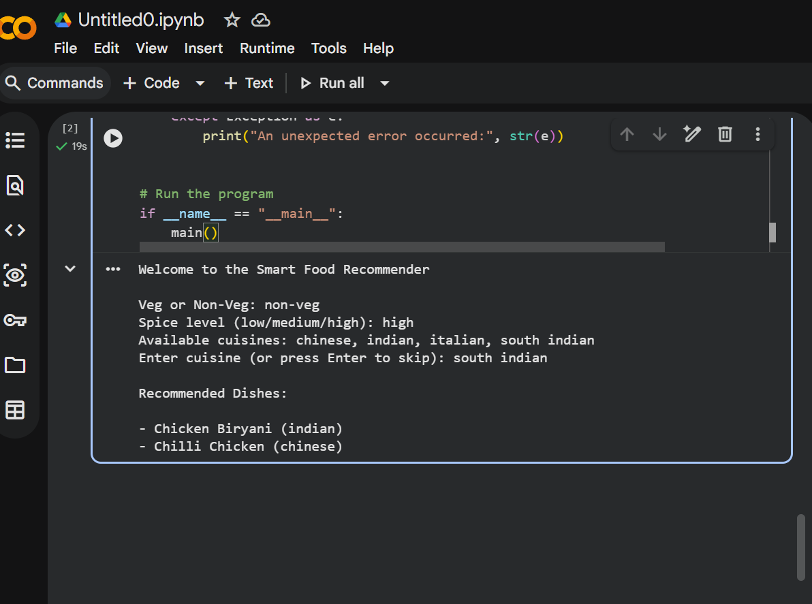

PROJECT BY :
Name: Sreepathi Leel Nihal Veronica Vardhan
Registration ID: 25BOE10051
Course: Bioengineering

